# 605.201

**Introduction to Programming Using Java Assignment 1**

Write a program that displays the following output:

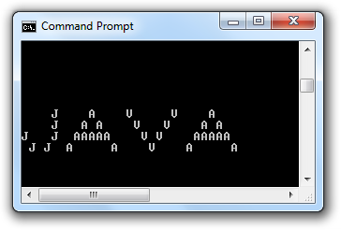

Follow the directions and submit per the document "Assignment and Project Submission.docx"